Name: ______________________________________________________ Period: _____________

**6th Grade Writing Syllabus**

2021-2022

Welcome to Peekskill Middle School. My name is Ms. Burke and this is my third year at Peekskill Middle School, and my fourth year teaching. I am looking forward to a great year with you all. I, along with the rest of the 6 South Team, are honored to be a part of your child’s education.

**What is Writing exactly?** 

The Grade 6 Writing Course is writing based on the Common Core Standards. This course will focus on the five styles of writing: Narrative Writing, Descriptive Writing, Persuasive Writing, Expository Writing, and Creative Writing.

In addition to longer works, students will also work on responding to open-ended questions, analyzing and focusing on the conventions of English grammar. Students will respond through conversation, writing, oral presentations, debates, and assessments. Students will be expected to write a minimum of three to five developed, benchmark pieces throughout the year to put into their writing portfolio. However, this course also takes a closer look at student’s writing and works to build and fine-tune the strategies that students use to express themselves. We want your child to grow with the necessary tools to be successful in today’s world while freely expressing themselves.

**Writing Units:**

This school year we will be studying different styles of writing throughout the following units.

**Unit One:** Personal Narrative(s)

**Unit Two:** Argumentative Writing

**Unit Three:** Poetry

**Unit Four:** Culturally Diverse Writing

**Unit Five:** Creative Writing

**Unit Six:** Final Assessments and Transitions

**Expectations:**

* This is OUR classroom and we are a TEAM. We must all work together in order to achieve our goals. My goal is to teach you the sixth grade writing standards in a safe, nurturing, engaging, and positive environment. I want you to enjoy writing as much as I do! Together we will set and maintain goals in order to have a successful school year.
* Please be on time, on task and prepared to learn each and every day.
* Respect adults, your peers, our classroom and yourself.
* Be responsible for your learning.
* Keep electronics stored away in your lockers.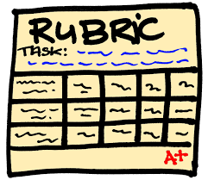

**Writing Assessments:**

All writing assessments will be graded using a **rubric** which will be discussed in depth before the students begin their work. All rubrics are based on a 4, 3, 2, 1 scale. While some of these writing assessments will be worked on and completed in class, others may require completion at home.

**Tests/Quizzes:**

Within each of our six units, the students will execute a unit assessment to assess their understandings of differentiated grammar as well as vocabulary.

**Homework:**

Homework assignments will often be the completion of a task that your child began in class. However, there will also be times when students will be asked to complete homework that targets specific content and skills that we are studying in class.

**Citizenship:**

In this class, being a good citizen and showing up prepared, will certainly help your child’s grade. By simply showing up to class every day with a positive attitude, and ready to work with the necessary tools, your child can earn five percent on their numerical average.

Please feel free to contact me if you have any questions or concerns.

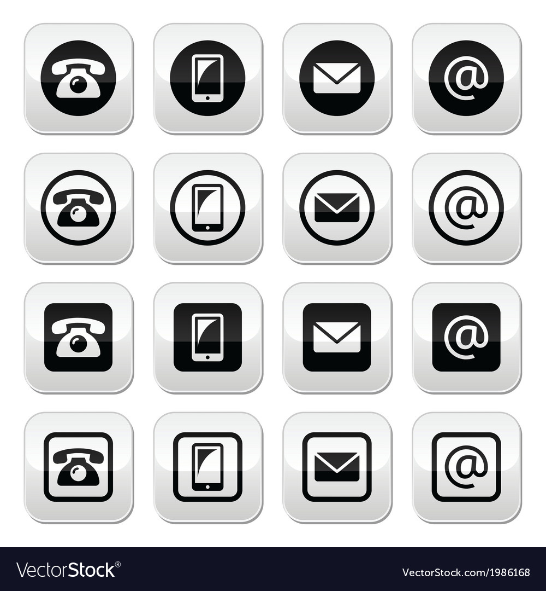

**jburke@peekskillschools.org**



**(914) 737-4542**

*\*Or you may message me on Class Dojo!\**